Data Cleaning & Preparation Documentation

Overview
This document describes the structure and preparation of the "cleaned" CSV datasets used in the Intervention Simulation Dashboard (app.py). These files contain pre-calculated regression coefficients derived from statistical models.

Data Source
The application loads data from the clean_data/ directory.
- Files:
pdiabe_cleaned.csv,
phearte_cleaned.csv,
phibpe_cleaned.csv,
pcogstate_cleaned.csv.
- Format: CSV.

Cleaning Steps
While the raw data processing happens upstream, the "cleaned" files exhibit the following characteristics, implying these preparation steps were taken:
- Transposition: The data appears to be transposed compared to standard regression output.
  - Rows (Index): Represent the terms in the regression equation (e.g., _cons, 2.year_inc, ivparm1).
  - Columns: Represent the specific outcome and subgroup combination (e.g., p_diabe_85p, n_hearte_all).
- Standardized Naming:
  - Index Column: The first column is unnamed in the CSV header but serves as the unique identifier for coefficients. It contains standardized Stata-style interaction terms (e.g., year_inc#c.ivparm1).
  - Column Headers: Follow a strict naming convention: [outcome]_[subgroup] (e.g., p_cogstate1_f for Dementia prevalence in Females).
- Coefficient Extraction: The values in the cells are the regression coefficients (beta) themselves, not raw population data.
- Imputation/Filling: Missing coefficients for certain terms (like specific year interactions) may be present as 0 or simply missing (handled by the app as 0).

Data Structure for Application
The app.py relies on this specific structure:
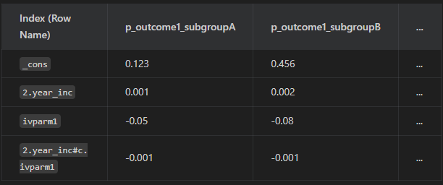

Key Terms
- _cons: The regression constant (intercept).
- N.year_inc: The coefficient for the N-th year from the start (2024).
- ivparm1: The main effect of the intervention.
- N.year_inc#c.ivparm1: The interaction effect of the intervention in year N.

Usage in Code
The application loads these files into a dictionary of Pandas DataFrames:
